KR MANGALAM UNIVERSITY



SECURE CODING AND VULNERABILTIES LAB
(ENSP 351)

Lab Assignments

Name - Sahil Chaudhary

Roll Number – 2301730193

B.Tech CSE AI/ML -( C )

Data Type Conversion — Unsafe Behaviour and Safe Implementation (Exp 1)
Code –
Unsafe -
#include <stdio.h>
#include <stdlib.h>

int main()
{
int a = 70000;
short s = (short)a;

int neg = -10;
unsigned int u = (unsigned int)neg;

float f = 12.99;
int i = (int)f;

char str[] = "123abc";
int num = atoi(str);

printf("=== Unsafe Conversions ===\n");

printf("int -> short\n");
printf("Before: %d\nAfter : %hd\n\n", a, s);

printf("signed -> unsigned\n");
printf("Before: %d\nAfter : %u\n\n", neg, u);

printf("float -> int\n");
printf("Before: %.2f\nAfter : %d\n\n", f, i);

printf("string -> int\n");
printf("Before: %s\nAfter : %d\n", str, num);

return 0;
}

Output –
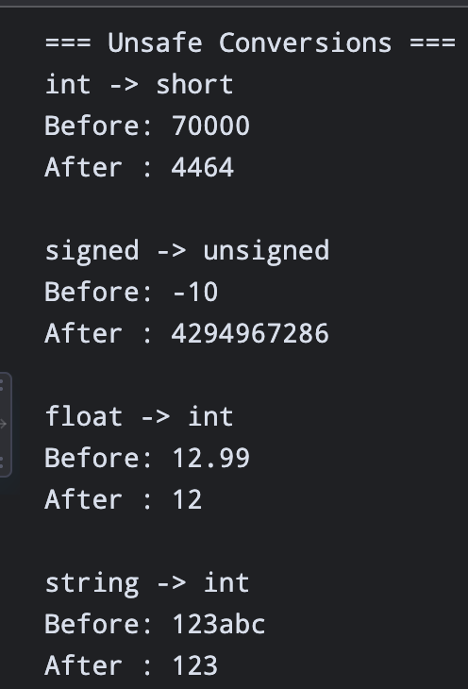
Safe –
Code-
#include <stdio.h>
#include <stdlib.h>
#include <limits.h>

int main()
{
int a = 70000;
int neg = -10;
float f = 12.99;
char str[] = "123abc";

printf("=== Safe Conversions ===\n");

if (a < SHRT_MIN || a > SHRT_MAX)
printf("Rejected: %d is out of short range\n", a);
else
printf("%hd\n", (short)a);

if (neg < 0)
printf("Rejected: negative value cannot be converted safely\n");
else
printf("%u\n", (unsigned int)neg);

printf("float -> int\n");
printf("Before: %.2f\nAfter : %d\n", f, (int)f);

char *end;
long value = strtol(str, &end, 10);

if (*end != '\0')
printf("Rejected: invalid numeric string '%s'\n", str);
else
printf("%ld\n", value);

return 0;
}

Output –
